
Company
Logotype

Cone Beam Computed Tomography- Report



Porur Dental X-rays & CBCT

Patient Name : Mr. Renin Martin | Date of Report : 11.09.2024
Age/ Gender : 43 years/ Male | Region of Interest : CBCT Full Skull
Referring doctor: Dr. S M. M. Moulvi | Indication : Implant assessment
Clinical Notes: Nil
PATIENT INFORMATION

CBCT- Full Skull provided
CBCT – IMAGE DETAILS

RADIOGRAPHIC INTERPRETATION

- Complete loss of crown and root structure in relation to 18, 28, 34, 36, 38, 44, 45, 48.
- Presence of hyperdense restorative material within the pulp canals of 35, 37, 43, 46 is evident.
- Presence of hyperdense screws (4 nos) and a straight surgical plate in the periapical region of 46, 47, 48 region is evident.
- In 31, 41 region, presence of the canal of lingual artery running horizontally from buccal to lingual aspect at an average distance of 6 mm from the alveolar ridge is evident.
- The alveolar ridge in relation to the maxillary and mandibular alveolar ridge is present with normal trabecular pattern.

IMPLANT ASSESSMENT

 | 45 region | 46 region | 47 region
Sub-Crestal (in mm) | 5.3 | 8.8 | 12.2
Mid- Crestal (in mm) | 6.3 | 9 | 12.3
Distance between alveolar ridge and the inferior alveolar nerve canal (in mm) | 11.6 | 10.5 | 11.2
Distance between alveolar ridge and the inferior border of mandible (in mm) | 24.1 | 20.4 | 21.8
 | 31 region | 32 region | 33 region | 34 region
Sub-Crestal (in mm) | 6.8 | 7 | 7.5 | 4.2
Mid- Crestal (in mm) | 7.2 | 7.3 | 8.1 | 5.5
Distance between alveolar ridge and the inferior border of mandible (in mm) | 20.9 | 16.9 | 13.2 | 26.4
 | 41 region | 42 region | 43 region | 44 region
Sub-Crestal (in mm) | 6.4 | 6.5 | 7.8 | 5.1
Mid- Crestal (in mm) | 7.2 | 6.8 | 7.8 | 5.5
Distance between alveolar ridge and the inferior border of mandible (in mm) | 20.2 | 19.5 | 14.9 | 24

 | 35 region | 36 region | 37 region
Sub-Crestal (in mm) | 8.4 | 5.9 | 9.9
Mid- Crestal (in mm) | 7.9 | 7.7 | 10.3
Distance between alveolar ridge and the inferior alveolar nerve canal (in mm) | 3.3 | 14.7 | 8.5
Distance between alveolar ridge and the inferior border of mandible (in mm) | 15.2 | 24.2 | 17.2

RADIOGRAPHIC IMPRESSION

- Partially edentulous maxillary and mandibular arch.
- Root canal treated: 35, 37, 43, 46
- Surgical plate and screws: right lower arch.

Kindly correlate with clinical findings


IMAGES FOR REFERENCE

RECONSTRUCTED PANORAMIC VIEW

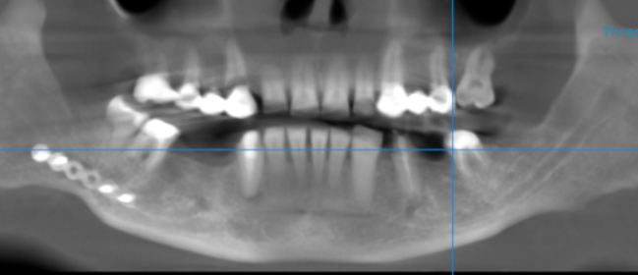

3-DIMENSIONAL VIEW

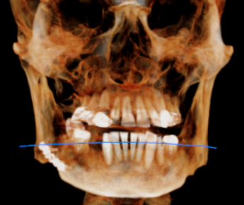

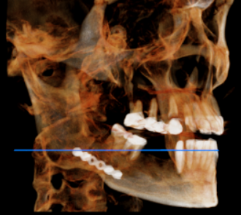
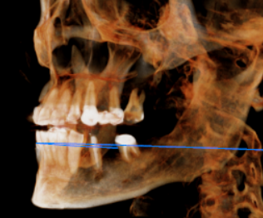

CROSS SECTIONAL VIEW

31 region | 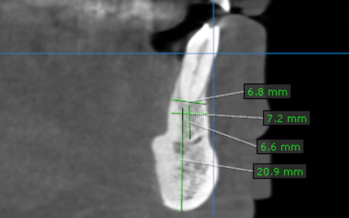
32 region | 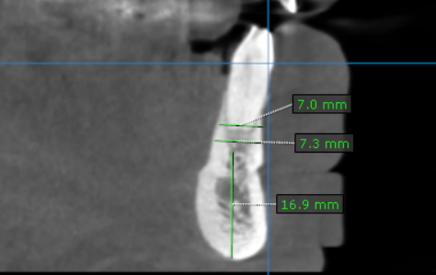
33 region | 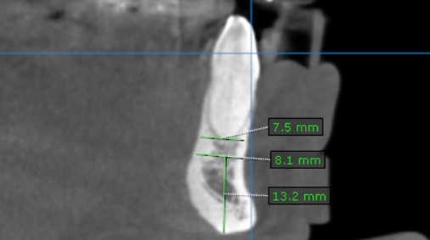
34 region | 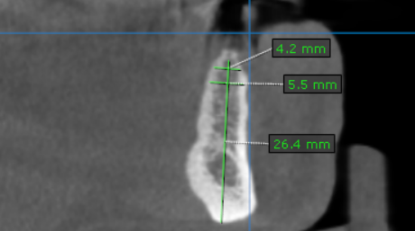
35 region | 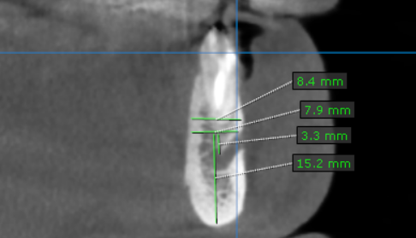
36 region | 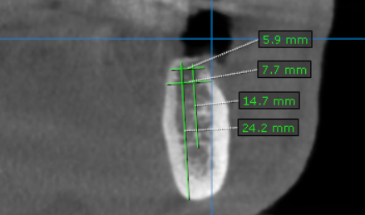
37 region | 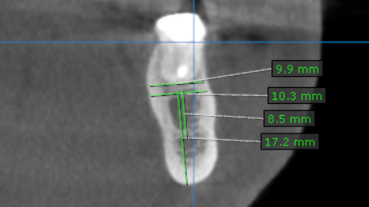
41 region | 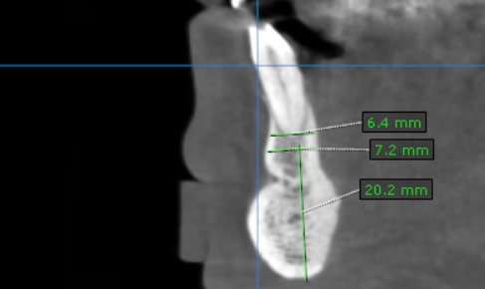
42 region | 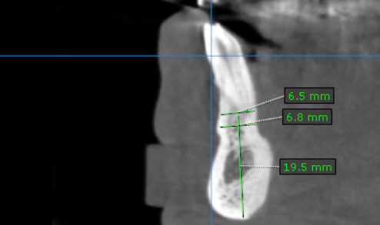
43 region | 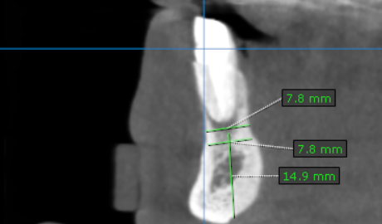
44 region | 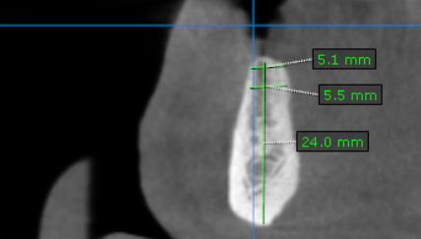
45 region | 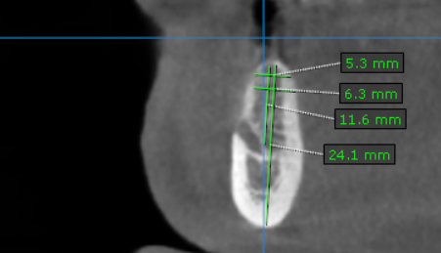
46 region | 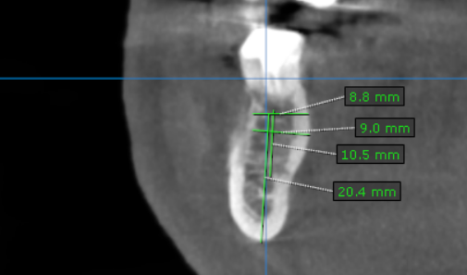
47 region | 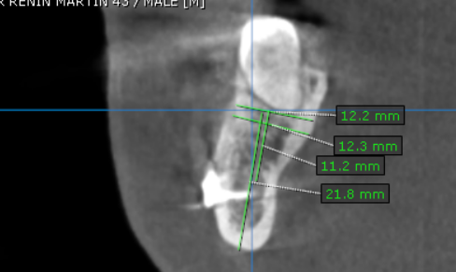

**** End of report ****

